
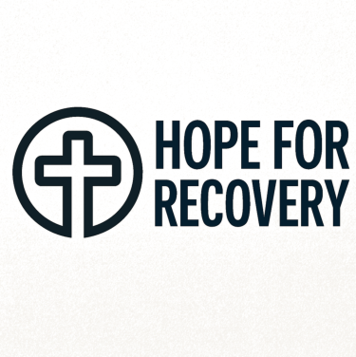

05/08/2025, 18:16 Hope for Recovery | Holistic Health Workbook
Hope for Recovery
Holistic Health Workbook
Hope, Healing, Wholeness
Welcome to the 12-Week Holistic Health Course
Over the next 12 weeks, we'll explore physical, emotional, mental, and spiritual health - their importance,
how to improve each area, and how they interconnect. Our prayer is that you'll grow into the person God
created you to be.
Course Completion: To earn a certificate, attend at least 6 sessions (50%) and score 50% on the final quiz.
For a merit certificate, attend 9 sessions (75%) and score 75%.
12-Week Plan Overview
file:///C:/Users/User1/Desktop/hope-for-recovery/workbooks/Holistic Health.html 1/20





05/08/2025, 18:16 Hope for Recovery | Holistic Health Workbook
Week 1 Week 2 Week 3 Week 4

Introduction to Holistic | Spirit, Soul & Body | Physical Health | Emotional Health
Health
Week 5 Week 6 Break Week 7

Personal Reflection | Living in the | Gratitude is the Best
 | Moment | Attitude
Week 8 Week 9 Week 10 Week 11

Mental Health | Spiritual Health | Awareness vs | Case Study
 |  | Awakening
Week 12 Certificates
Final Assessment
Group Rules
1. No attendance under the influence of substances
2. No sharing or requesting illicit drugs/alcohol
3. If late, enter quietly and notify if possible
4. Respect confidentiality
file:///C:/Users/User1/Desktop/hope-for-recovery/workbooks/Holistic Health.html 2/20





05/08/2025, 18:16 Hope for Recovery | Holistic Health Workbook
5. One person speaks at a time
6. No cross-talking
7. Support, don't "fix" others
8. Limit sharing to 3-5 minutes
9. Avoid glorifying addictive behaviors
10. Maintain a positive attitude
11. Silence mobile devices
12. Refreshments during breaks only
13. Embrace truth, honesty, and respect
Week 1: Introduction to Holistic Health
To begin, rank the four health components by importance and rate your current status (1-10):
Health Area Importance (Rank 1-4) Current Score (1-10)
Physical
Mental
Spiritual
Emotional
file:///C:/Users/User1/Desktop/hope-for-recovery/workbooks/Holistic Health.html 3/20


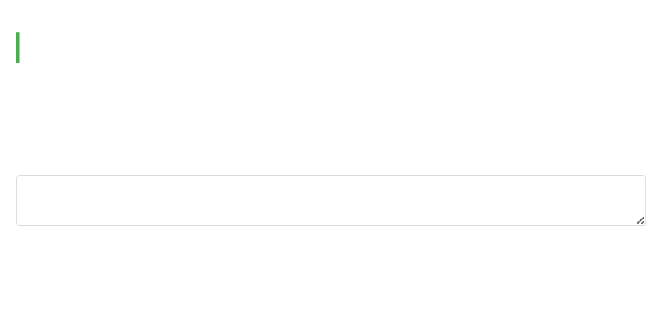


05/08/2025, 18:16 Hope for Recovery | Holistic Health Workbook
Reflection: Why did you choose this order? How might it change by Week 12?
Write your thoughts here...
Memory Verse (1 Corinthians 15:45):
"The spiritual did not come first, but the natural, and after that the spiritual."
This verse reminds us that while physical health is important, spiritual growth follows as we mature.
Week 2: Spirit, Soul & Body
Mankind is a triune being made up of three parts: spirit, soul, and body. Today we'll explore the purpose of
each component.
1. What is the purpose of your spirit?
Discuss in your group and write your thoughts here...
2. What is the purpose of your soul?
file:///C:/Users/User1/Desktop/hope-for-recovery/workbooks/Holistic Health.html 4/20





05/08/2025, 18:16 Hope for Recovery | Holistic Health Workbook
Discuss in your group and write your thoughts here...
3. What is the purpose of your physical body?
Discuss in your group and write your thoughts here...
Memory Verse (1 Thessalonians 5:23b):
"May your whole spirit, soul and body be kept blameless at the coming of our Lord Jesus Christ."
This verse emphasizes the importance of caring for all parts of our being.
Week 3: Physical Health
Today we'll explore physical health - what it is, its benefits, and how to improve it.
1. How would you define physical health?
Group discussion notes...
file:///C:/Users/User1/Desktop/hope-for-recovery/workbooks/Holistic Health.html 5/20



05/08/2025, 18:16 Hope for Recovery | Holistic Health Workbook
2. What are the benefits of good physical health?
Group discussion notes...
3. Ways to improve physical health:
Action Plan: Check goals you want to work on:
Regular exercise (3+ times/week)
Balanced nutrition (fruits/vegetables daily)
7-8 hours of sleep nightly
Annual medical check-ups
Hydration (8 glasses of water daily)
Other: Specify
Memory Verse (3 John 1:2):
"Dear friend, I pray that you may enjoy good health and that all may go well with you, even as your soul
is getting along well."
This shows God's desire for our physical and spiritual well-being.
file:///C:/Users/User1/Desktop/hope-for-recovery/workbooks/Holistic Health.html 6/20



05/08/2025, 18:16 Hope for Recovery | Holistic Health Workbook
Week 4: Emotional Health
Today we explore emotional health - how to understand and manage our emotions for a happier life.
1. How would you define emotional health?
Group discussion notes...
2. How might good emotional health help someone in addiction recovery?
Group discussion notes...
3. Ways to increase emotional health:
Emotional Health Toolkit:
Identify and name your emotions daily
Practice deep breathing when stressed
Journal about your feelings
Talk to trusted friends or counselors
Other: Specify
Memory Verse (Romans 12:2):
file:///C:/Users/User1/Desktop/hope-for-recovery/workbooks/Holistic Health.html 7/20


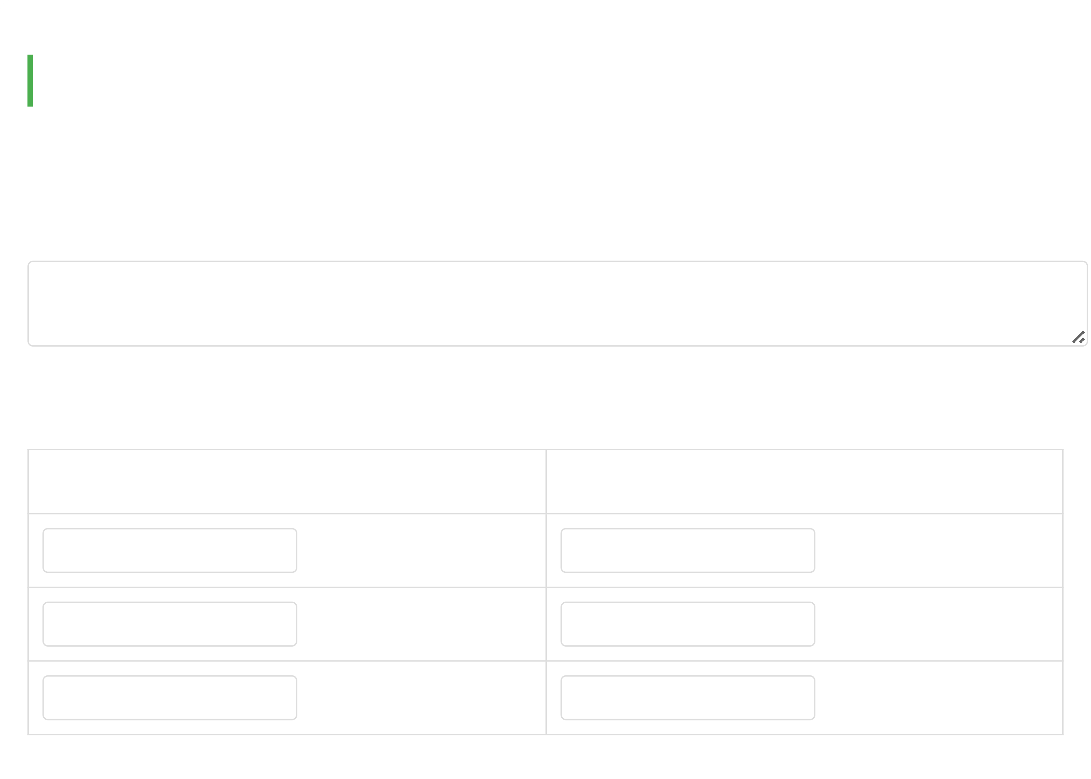

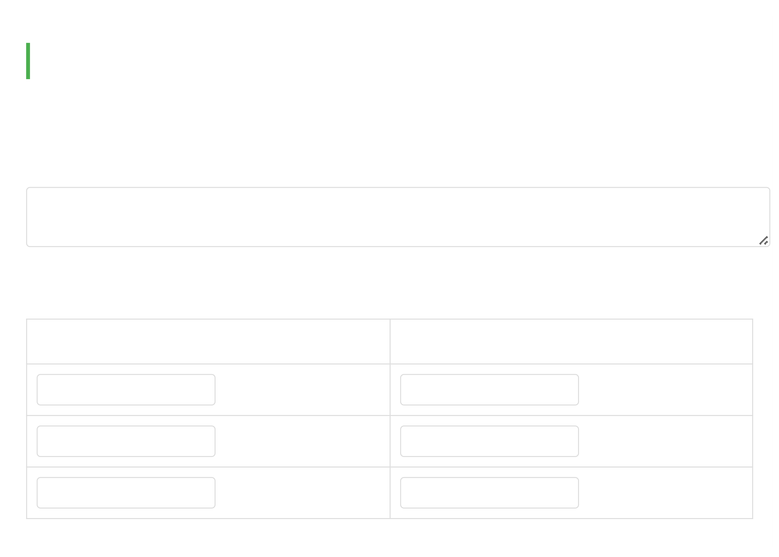
05/08/2025, 18:16 Hope for Recovery | Holistic Health Workbook
"Do not conform to the pattern of this world, but be transformed by the renewing of your mind."
Emotional health begins with how we think and perceive our experiences.
Week 5: Personal Reflection
Continuing our look at emotional health, we'll reflect on our emotional state and its causes.
1. What are emotions and why do we have them?
Your thoughts...
2. List negative and positive emotions:
Negative Emotions Positive Emotions
e.g., anger e.g., joy
file:///C:/Users/User1/Desktop/hope-for-recovery/workbooks/Holistic Health.html 8/20





05/08/2025, 18:16 Hope for Recovery | Holistic Health Workbook
Which list would you rather live from and why?
Your response...
3. Your emotional state this week:
Emotional State Why?
Negative/Positive Reasons
Memory Verse (Galatians 5:16):
"Walk by the Spirit, and you will not gratify the desires of the flesh."
Our spiritual walk directly impacts our emotional health.
Week 6: Living in the Moment
Today we begin exploring mental health - starting with the principle of living in the present.
Principle (Matthew 6:34):
file:///C:/Users/User1/Desktop/hope-for-recovery/workbooks/Holistic Health.html 9/20





05/08/2025, 18:16 Hope for Recovery | Holistic Health Workbook
"Therefore do not worry about tomorrow, for tomorrow will worry about itself."
1. What might be advantages of worrying?
Group discussion notes...
2. What are disadvantages of worrying?
Group discussion notes...
3. How can we apply this "present moment" principle daily?
Mindfulness Practices:
Pause and breathe when anxious
Focus on one task at a time
Notice sensory details (sights, sounds)
Other: Specify
Week 7: Gratitude is the Best Attitude
file:///C:/Users/User1/Desktop/hope-for-recovery/workbooks/Holistic Health.html 10/20







05/08/2025, 18:16 Hope for Recovery | Holistic Health Workbook
Continuing mental health principles, we explore how gratitude improves our mindset.
Principle (1 Thessalonians 5:18):
"Give thanks in all circumstances, for this is God's will for you in Christ Jesus."
1. List three things you're thankful for:
1.
2.
3.
2. Benefits of a grateful attitude:
Group discussion notes...
3. How to practice gratitude daily:
Gratitude Practices:
Keep a gratitude journal
Share thanks during meals
Thank someone daily
file:///C:/Users/User1/Desktop/hope-for-recovery/workbooks/Holistic Health.html 11/20




05/08/2025, 18:16 Hope for Recovery | Holistic Health Workbook
Other: Specify
Week 8: Mental Health
Today we explore mental health - what it is, how it differs from physical health, and ways to improve it.
1. Words associated with mental vs. physical health:
Mental Health Physical Health
e.g., thoughts e.g., exercise
2. How would you define mental health?
Group discussion notes...
3. Ways to improve mental health:
Mental Wellness Strategies:
file:///C:/Users/User1/Desktop/hope-for-recovery/workbooks/Holistic Health.html 12/20





05/08/2025, 18:16 Hope for Recovery | Holistic Health Workbook
Challenge negative thoughts
Engage in stimulating activities
Practice relaxation techniques
Other: Specify
Memory Verse (Psalm 42:5):
"Why, my soul, are you downcast? Put your hope in God."
When our minds are troubled, we can turn to God for peace.
Week 9: Spiritual Health
Today we begin exploring spiritual health - what it is, its benefits, and how to nurture it.
1. How would you define spiritual health?
Group discussion notes...
2. How might spiritual health help someone in addiction?
file:///C:/Users/User1/Desktop/hope-for-recovery/workbooks/Holistic Health.html 13/20



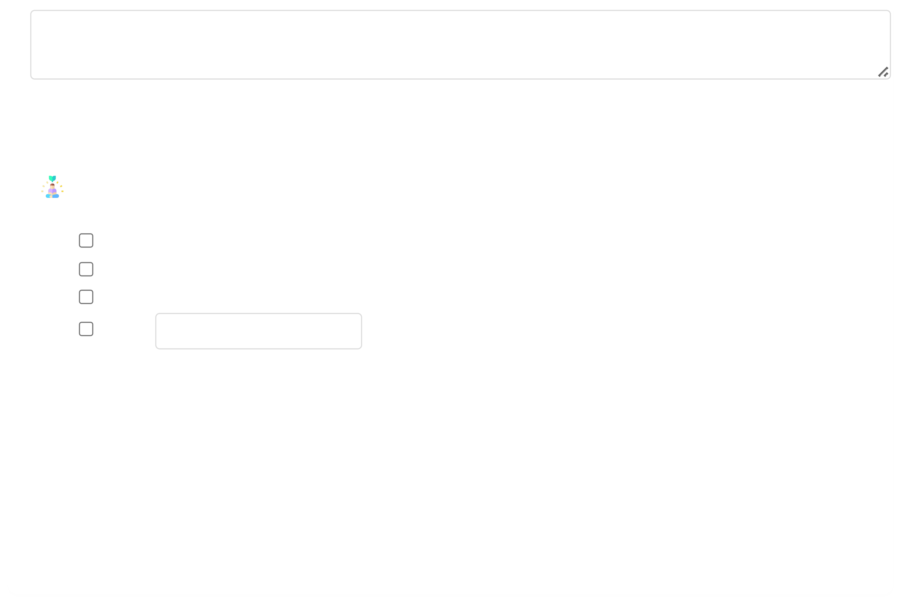

05/08/2025, 18:16 Hope for Recovery | Holistic Health Workbook
Group discussion notes...
3. Ways to increase spiritual health:
Spiritual Growth Practices:
Daily prayer/meditation
Scripture reading
Worship participation
Other: Specify
Memory Verse (Ephesians 3:16):
"I pray that out of his glorious riches he may strengthen you with power through his Spirit in your inner
being."
Spiritual health comes from God's strength within us.
Week 10: Awareness vs. Awakening
Continuing spiritual health, we explore whether spirituality requires awareness or awakening.
file:///C:/Users/User1/Desktop/hope-for-recovery/workbooks/Holistic Health.html 14/20



05/08/2025, 18:16 Hope for Recovery | Holistic Health Workbook
1. Is spirituality about awareness or awakening?
Group discussion notes...
2. How might spirituality be awakened in someone?
Group discussion notes...
3. What hinders spiritual awakening? How to overcome?
Hindrances Solutions
e.g., doubt e.g., prayer
Memory Verse (John 10:10):
"I have come that they may have life, and have it to the full."
Jesus offers us complete spiritual awakening and abundant life.

file:///C:/Users/User1/Desktop/hope-for-recovery/workbooks/Holistic Health.html

15/20



05/08/2025, 18:16 Hope for Recovery | Holistic Health Workbook
Week 11: Case Study - John's Story
John has been a Christian for 18 years but struggles with guilt and relapses into heroin use. He feels
disconnected from God and unworthy of love.
1. How would you describe John's spiritual health?
Group discussion notes...
2. How might you help John improve his spiritual health?
Group discussion notes...
3. What positive impacts might improved spiritual health have on John's life?
Group discussion notes...
Memory Verse (Colossians 1:14):
"In whom we have redemption, the forgiveness of sins."
file:///C:/Users/User1/Desktop/hope-for-recovery/workbooks/Holistic Health.html 16/20





05/08/2025, 18:16 Hope for Recovery | Holistic Health Workbook
John needs to embrace God's complete forgiveness.
Week 12: Final Assessment
Re-evaluate your holistic health components and compare to Week 1:
Health Area Importance (Rank 1-4) Current Score (1-10)
Physical
Mental
Spiritual
Emotional
Reflection:
How has your understanding of holistic health changed during this course?
Your reflections...
file:///C:/Users/User1/Desktop/hope-for-recovery/workbooks/Holistic Health.html 17/20




05/08/2025, 18:16 Hope for Recovery | Holistic Health Workbook
What specific changes have you made in each area?
Your progress...
Memory Verse (Ephesians 5:18):
"Be filled with the Spirit."
As we conclude, may you continue to be filled with God's Spirit in all areas of life.
Course Feedback
1. Which week was most impactful for you? Why?
2. What specific changes have you noticed in these areas?
Physical health
Emotional well-being
Mental clarity
Spiritual growth

file:///C:/Users/User1/Desktop/hope-for-recovery/workbooks/Holistic Health.html

18/20



05/08/2025, 18:16 Hope for Recovery | Holistic Health Workbook
Other:
3. How could we improve this course?
Additional Resources
Recommended Reading:
The Whole Person Recovery by Dr. Sarah Johnson
Mind-Body-Spirit Connection by Rev. Michael Brown
Addiction and Grace by Gerald May
Support Tools:
Meditation apps: "Calm", "Headspace", or "Abide" (Christian meditation)
Fitness/nutrition: "MyFitnessPal" or "Cronometer"
Bible study: "YouVersion Bible App"
Local Support:
Contact Hope for Recovery for information about ongoing support groups and counseling services.

file:///C:/Users/User1/Desktop/hope-for-recovery/workbooks/Holistic Health.html

19/20

05/08/2025, 18:16 Hope for Recovery | Holistic Health Workbook
Copyright © Hope for Recovery | September 2023 | Craig Halkett

file:///C:/Users/User1/Desktop/hope-for-recovery/workbooks/Holistic Health.html

20/20

